MA 585 project report

Reported by: Leshen Sui

Dataset: google stock weekly data from 2013 Jan. to 2016 Apr.

Datasource:http://finance.yahoo.com/q/hp?s=GOOG&a=00&b=1&c=2013&d=03&e=1&f=2016&g=m

Data Introduction:

The google stock price data is chosen from finance.yahoo.com, and to ensure that data are new I only select data in most recent 3 years. The original data set contains many kinds of price(open, close, adjust close...), and I chose the adjust price of google stock as my covariant. Luckily there is no missing data, and by ploting the data I didn’t see any data point “stand out”, so I assume there is no outlier. Then I imported the dataset to R and did some analysis.

Model Construction:

1. Via classical decomposition Xt = Yt + Nt, Yt is some polynomial with respect to time t, and Nt is some stationary and causal ARMA process. here I assume there is no seasonal pattern.
2. Via differencing, construct a model in arima class. Model selection by MLE approach.

Model diagnostic:

Ljung-Box test

Prediction:

1. Predict by Xt = Yt + Nt
2. Predict by ARIMA model
3. Predict by Holt-Winter method

For the model construction, model selection, model diagnostic and prediction part, a detail explanation will be presented later.

Conclusion:

Among all candidate models given by the classical decomposition and differerencing, ARIMA(0,1,1) model with drift tends to be the best. On the one hand, it is the MLE model of the arima class, on the other hand, it passes the Ljung-Box test and have a small prediction error compared with the classical decomposition Xt = Yt + Nt (much smaller mae, rmse and mape). The ARIMA(0,1,1) model is given by:

**Xt - X(t-1) = et - 0.2232*e(t-1) + 2.2411**

Also, for the purpose of prediction, the Holt-Winter forecast gives the same precise prediction as the above arima model. Besides, other than only giving a constant prediction for the future values, the Holt-Winter prediction can capture the increasing trend of the data, therefore in order to predict the stock price in a long term, Holt-Winter forecast will give better predictions.

The code and data are attached at the very back of the report as appendix.

Overview:

Google is getting hotter and hotter these years by making tremendous breakthrough in technologies, expecially after releasing the software alphaGo. It is interesting to analize google stock price in recent years to see if there is any discernable pattern, which can guide people who want to invest money on google stock. In my analysis I went over two basic approach: the classical decomposition and differencing approach, following by model selection, model diagnostic and prediction. Then choose the best fitted model as the final conclusion. Let’s first look at the original data plot:

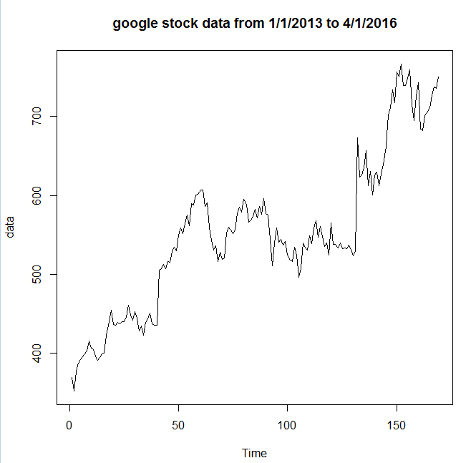

Here I got 170 data, which is enough for the analysis, in order to validate my model I treat the first 160 data as the training data, which are the exist data to bulid the model, and I treat the last 10 data as the testing data, helping me to know how well my model works.

The training data:

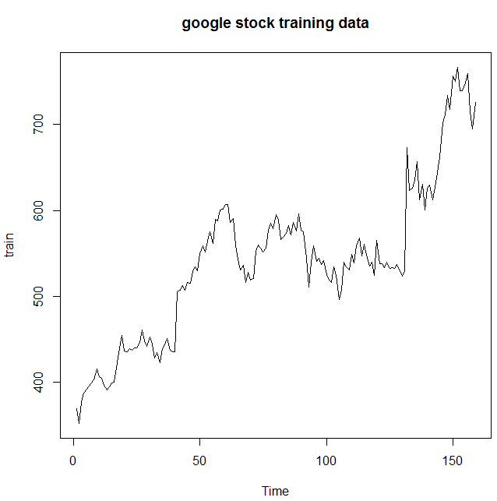

Now comes to the data analysis part. First try a classical decomposition approach:

First by visualizing the data I found there is an increasing trend, which is expected because Google company kept making achievements. But there is no obvious seasonal pattern. Therefore we can build the model X(t) = y(t) + N(t), where y(t) is the trend part (some function of t) and a noise part(a stationary process). Notice that the variance is not stable, so a suitable box-cox transformation may be needed:

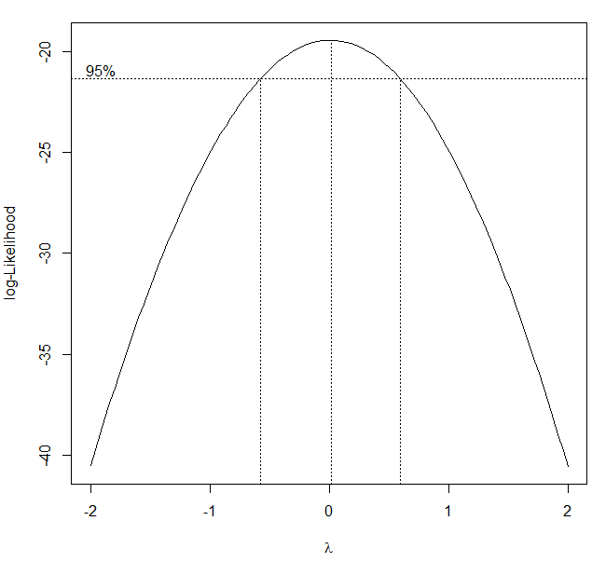

As the plot suggested, a log transformation is reasonable (lambda = 0 is the mle):

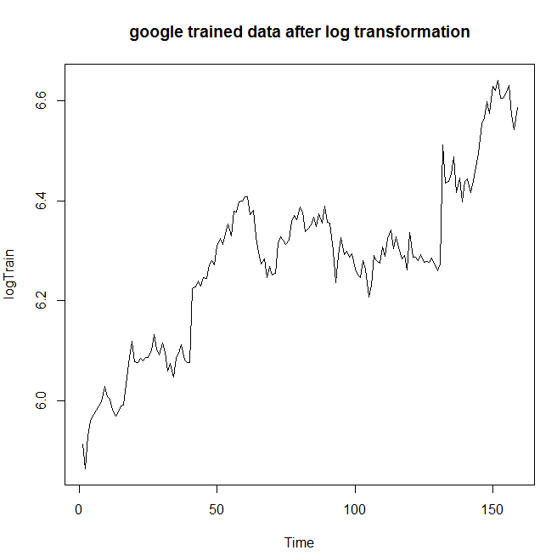

So fit the trend by a linear function y(t) = kt + b

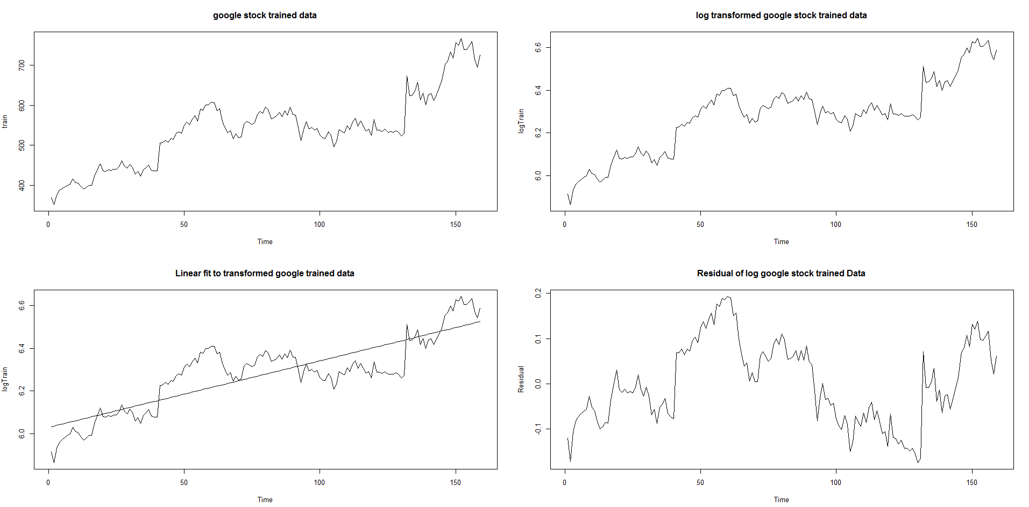

We can see the residual is not very ramdom, so Var(X(t) - y(t)) may still depend on t. This can also be verified by the ACF and PACF plot of the residuals(The ACF plot not follows an exponential decay):

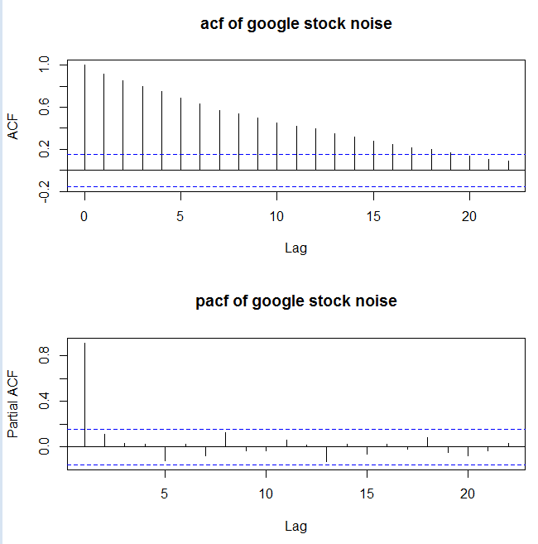

So try to fit y(t) by a higher order polynomial, start from order 2, and keep adding the highest power:

y(t) = k2*t2^2 + k1*t1 + k0

y(t) = k3*t3^3 + k2*t2^2 + k1*t1 + k0

y(t) = k4*t4^4 + k3*t3^3 + k2*t2^2 + k1*t1 + k0

y(t) = k5*t5^5 + k4*t4^4 + k3*t3^3 + k2*t2^2 + k1*t1 + k0

......

Plot the fitted result below:

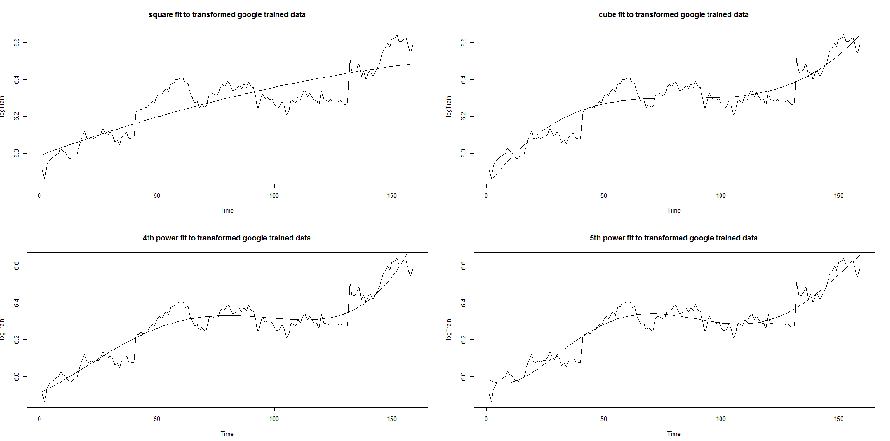

And the resudual plots:

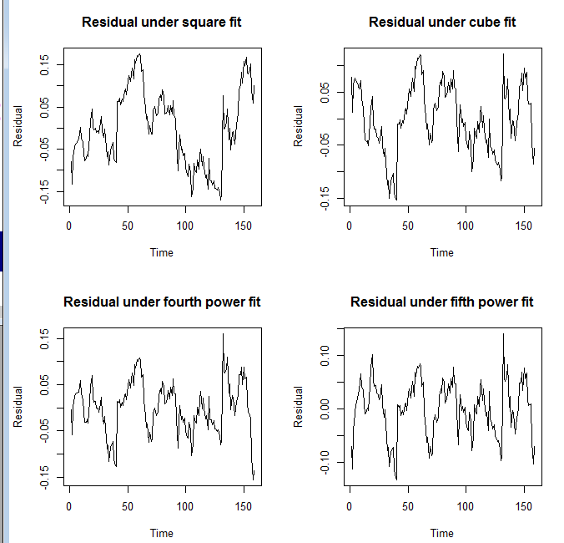

As expected, the noise part looks more random as the highest power goes up. The resudial under the fifth power fit is approximately 0 mean and stable variance. Also, all parameters are significant.

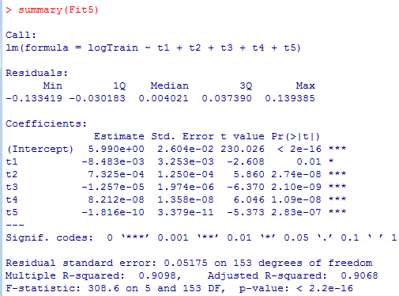

Also, by looking at the ACF and PACF plot of the resuduals:

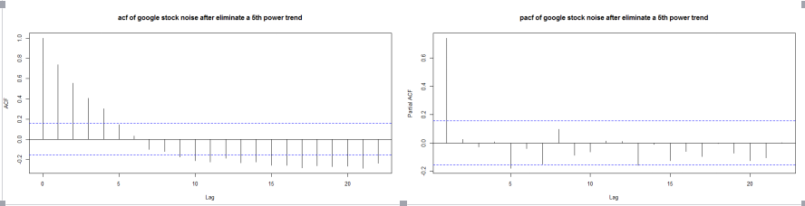

The ACF is exponentially decay(approximately) and the PACF cuts off after lag 1. So we can use an AR(1) model for the noise part, and by MLE estimation:

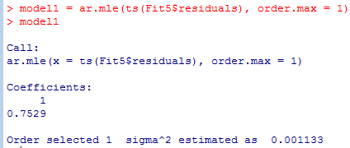

So for the N(t) part we can use the AR(1) model N(t) - 0.7529N(t - 1) = et (according to the residual plot, mu = 0).

**Model diagnostic: Ljung-Box test**

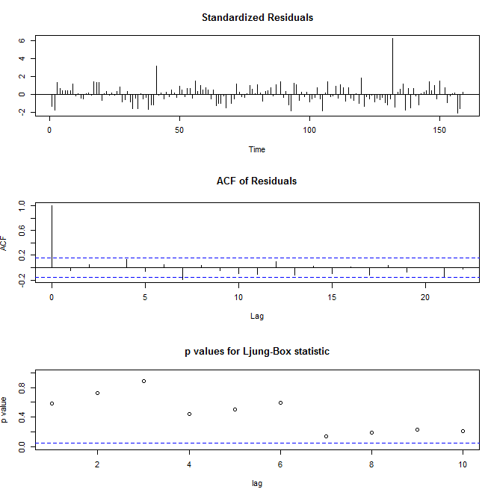

So we can see AR(1) model is a very good fit for the noise part, since the ACF of residual are all not significant except at lag 0(a white noise), so there is little information left.

**Now it’s time for prediction:**

The forecast procedure is a little tedious, basically I predict the Noise part Nt by our AR(1) model constructed above, then add the trend component Yt, which is a fifth order polynomial. Then I have to exponentiate the results I got by Yt + Nt. In another word, the future value exp(X(t+l)) can be computed by exp(Y(t+l) + N(t + l)), assume Xt is the data after log transformation.

First forecast the noise by our AR(1) model:

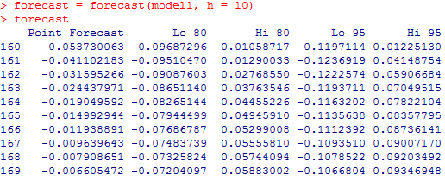

Add the trend component:

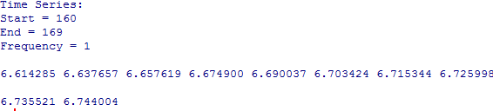

Exponentiate:

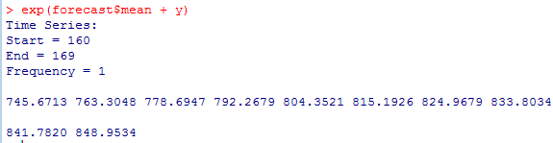

True value:



Find the error, compute mae, rsme, mape:

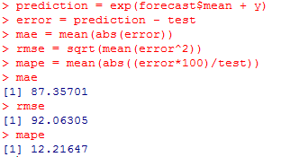

**So the prediction error is quite large, which motivates me to try another approch, which is differencing.**

First do the unitroot test to make sure there is at least one unit root:

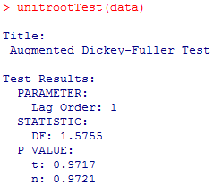

P-value is signigicant, so we can apply one difference, then do another unit root test for the differenced data to make sure one difference is enough(no need for differencing the differenced data).

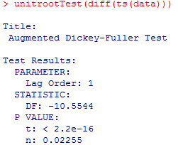

After one difference the p value becomes not significant, so no unit root after the first difference, and the data is stationary after first difference. Plot the differenced training data and its corresponding ACF and PACF:

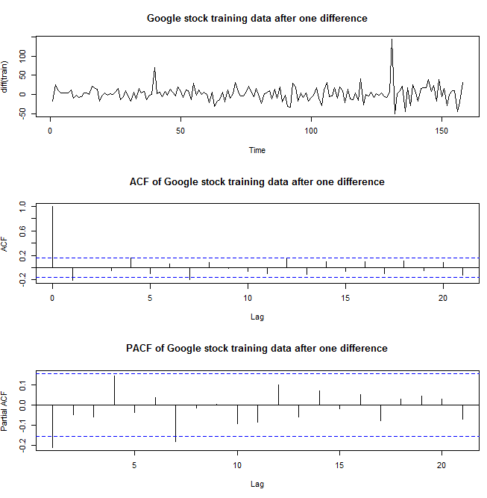

The ACF and PACF are both exponential decaying, so it’s reasonable to try some lower order ARMA model, However, it’s hard to find a reasonable model only by visualizing the plots, so I conducted a model selection step.

**Model Selection via MLE approach:**

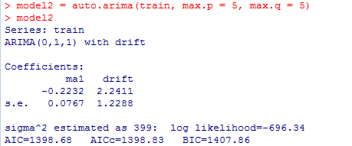

So it is suggested that an ARIMA(0,1,1) model with drift 2.2411 is the best possible model for the given data, and the coefficient for the MA part is -0.2232.

**Model 2: Xt(1 - B) = et - 0.2232*e(t-1) + 2.2411**

**Model diagnostic:Ljung-Box test**

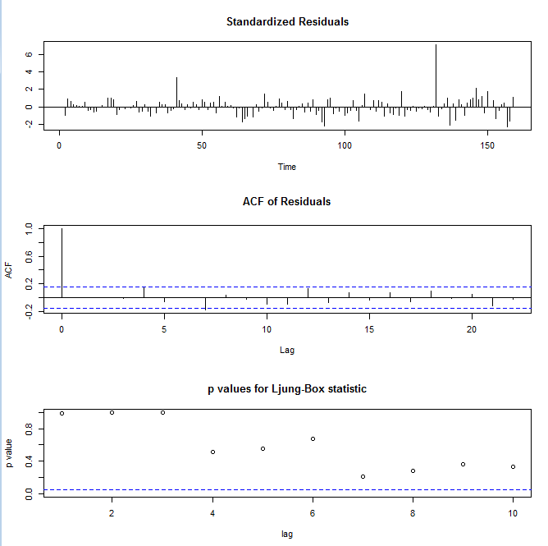

From the ACF of residual we can conclude that the residuals basically follows a white noise process, none of the acf are significant excapt at lag 0. Our ARIMA(0,1,1) model almost extract all information.

**Prediction**

First get the predicted value for the next 10 data:

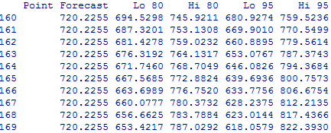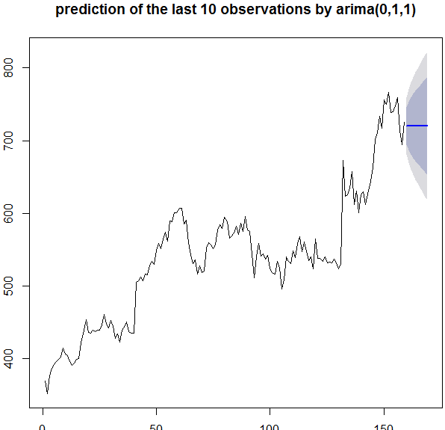

Compute the error, mae, rmse and mape:

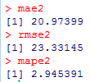

Notice that the all three values become much smaller compared to the classical decomposition approach. So the model in the classical decomposition is out.

**Finally try Holt-Winter forecast, compare the result with the ARIMA(0,1,1) model:**

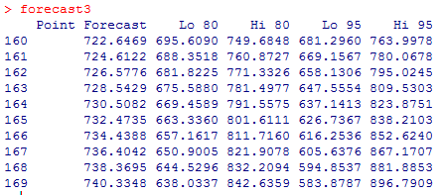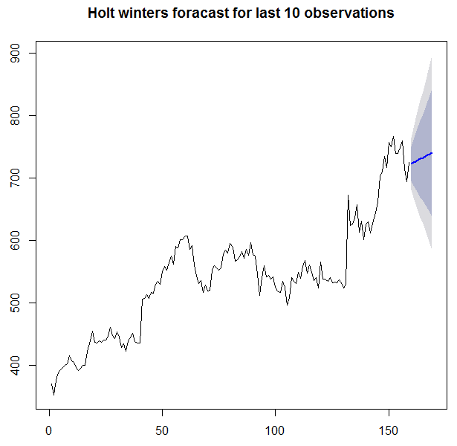

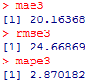

Notice that the Holt-Winter forecast has a lower mae and mape than the ARIMA(0,1,1) prediction, but has a higher rmse, but these a values are really close. So it’s hard to say which one did a better job. However, the Holt-Winter prediction did a better job in the long run because it capture the increasing trend of the google stock data, but in a short term (one or two days in the future) it’s reasonable to use the ARIMA(0,1,1) model because the values don’t have a big chance to change much, therefore the conditional mean gives a good guess.

Conclusion: see the front page.

Code Appendix

> project<-read.csv(file.choose())

> data = project[2]

> train = data[2:160,]

> test = data[161,170]

> t1 = c(1:length(logTrain))

> t2 = t1^2

> t3 = t1^3

> t4 = t1^4

> t5 = t1^5

> Fit2 = lm(logTrain~t1 + t2)

> Fit3 = lm(logTrain~t1 + t2 + t3)

> Fit4 = lm(logTrain~t1 + t2 + t3 + t4)

> Fit5 = lm(logTrain~t1 + t2 + t3 + t4 + t5)

> plot(data)

> ts.plot(data)

> ts.plot(data, main = "google stock data from 1/1/2014 to 4/1/2016")

> ts.plot(data, main = "google stock data from 1/1/2013 to 4/1/2016")

>library(MASS)

>boxcox(train~c(1:length(train)))

> logTrain = log(train)

> ts.plot(logTrain, main = "google trained data after log transformation")

> ts.plot(train)

> ts.plot(train, main = "google stock training data")

> par(mfrow=c(2,2))

> ts.plot(logTrain, main = "square fit to transformed google trained data")

> lines(ts(Fit2$fitted.values))

> ts.plot(logTrain, main = "cube fit to transformed google trained data")

> lines(ts(Fit3$fitted.values))

> ts.plot(logTrain, main = "4th power fit to transformed google trained data")

> lines(ts(Fit4$fitted.values))

> ts.plot(logTrain, main = "5th power fit to transformed google trained data")

> lines(ts(Fit5$fitted.values))

> par(mfrow=c(2,2))

> plot(ts(Fit2$residuals),ylab="Residual", main = "Residual under square fit")

> plot(ts(Fit3$residuals),ylab="Residual", main = "Residual under cube fit")

> plot(ts(Fit4$residuals),ylab="Residual", main = "Residual under fourth power fit")

> plot(ts(Fit5$residuals),ylab="Residual", main = "Residual under fifth power fit")

> acf(ts(Fit5$residuals), main = "acf of google stock noise after eliminate a 5th power trend")

> pacf(ts(Fit5$residuals), main = "pacf of google stock noise after eliminate a 5th power trend")

> model1 = ar.mle(ts(Fit5$residuals), order.max = 1)

> model1

>tsdiag(arima(Fit5$residuals,order=c(1,0,0)))

> x = coef(summary(Fit5))

> t = c(160:169)

> y = x[1,1] + x[2,1]*t + x[3,1]*t^2 + x[4,1]*t^3 + x[5,1]*t^4 + x[6,1]*t^5

>forecast = forecast(model1, h = 10)

> forecast

> forecast$mean + y

> exp(forecast$mean + y)

> prediction = exp(forecast$mean + y)

> error = prediction - test

> mae = mean(abs(error))

> rmse = sqrt(mean(error^2))

> mape = mean(abs((error*100)/test)

> library("fUnitRoots")

> unitrootTest(data)

> unitrootTest(diff(ts(data)))

> tsdiag(model2)

> fit2 = arima(train, order = c(0,1,1))

> forecast(fit2, h = 10)

> plot(forecast(fit2),main = "prediction of the last 10 observations by arima(0,1,1)")

> forecast2 = forecast(fit2, h = 10)

> err2 = test - forecast2$mean

> mae2 = mean(abs(err2))

> rmse2 = sqrt(mean(err1^2))

> mape2 = mean(abs((err2*100)/test))

> fit3 = HoltWinters(ts(train), gamma = F)

> plot(forecast3, main = "Holt winters foracast for last 10 observations")

> plot(forecast3, main = "Holt winters foracast for last 10 observations")

> err3 = test - forecast3$mean

> forecast3 = forecast(fit3, h = 10)

> plot(forecast3, main = "Holt winters foracast for last 10 observations")

> err3 = test - forecast3$mean

> mae3 = mean(abs(err3))

> mape3 = mean(abs((err3*100)/test))

> rmse3 = sqrt(mean(err3^2))

Data appendix:

|  |  |
| --- | --- |
| Date | AdjClose price of Google stock |
| 1/2/2013 | 368.617004 |
| 1/7/2013 | 369.626007 |
| 1/14/2013 | 351.903717 |
| 1/22/2013 | 376.459167 |
| 1/28/2013 | 387.413269 |
| 2/4/2013 | 392.293396 |
| 2/11/2013 | 396.049622 |
| 2/19/2013 | 399.456238 |
| 2/25/2013 | 402.692993 |
| 3/4/2013 | 415.345367 |
| 3/11/2013 | 406.743958 |
| 3/18/2013 | 404.750946 |
| 3/25/2013 | 396.698975 |
| 4/1/2013 | 391.134552 |
| 4/8/2013 | 394.631042 |
| 4/15/2013 | 399.536133 |
| 4/22/2013 | 400.310394 |
| 4/29/2013 | 422.438293 |
| 5/6/2013 | 439.676086 |
| 5/13/2013 | 454.136658 |
| 5/20/2013 | 436.224518 |
| 5/28/2013 | 435.175598 |
| 6/3/2013 | 439.426331 |
| 6/10/2013 | 437.083679 |
| 6/17/2013 | 440.025726 |
| 6/24/2013 | 439.746002 |
| 7/1/2013 | 446.299469 |
| 7/8/2013 | 461.039764 |
| 7/15/2013 | 447.852936 |
| 7/22/2013 | 442.233521 |
| 7/29/2013 | 452.832947 |
| 8/5/2013 | 444.760986 |
| 8/12/2013 | 428.02771 |
| 8/19/2013 | 434.671082 |
| 8/26/2013 | 423.02771 |
| 9/3/2013 | 439.351379 |
| 9/9/2013 | 444.091675 |
| 9/16/2013 | 451.104675 |
| 9/23/2013 | 437.757996 |
| 9/30/2013 | 435.73999 |
| 10/7/2013 | 435.560181 |
| 10/14/2013 | 505.200653 |
| 10/21/2013 | 507.093781 |
| 10/28/2013 | 513.007874 |
| 11/4/2013 | 507.508362 |
| 11/11/2013 | 516.264648 |
| 11/18/2013 | 515.43042 |
| 11/25/2013 | 529.266602 |
| 12/2/2013 | 534.40155 |
| 12/9/2013 | 529.866028 |
| 12/16/2013 | 549.761169 |
| 12/23/2013 | 558.642334 |
| 12/30/2013 | 551.948975 |
| 1/6/2014 | 564.526428 |
| 1/13/2014 | 574.691284 |
| 1/21/2014 | 561.354614 |
| 1/27/2014 | 589.896118 |
| 2/3/2014 | 588.132874 |
| 2/10/2014 | 600.800232 |
| 2/18/2014 | 601.294739 |
| 2/24/2014 | 607.218811 |
| 3/3/2014 | 606.789246 |
| 3/10/2014 | 585.815247 |
| 3/17/2014 | 590.930054 |
| 3/24/2014 | 559.992554 |
| 3/31/2014 | 543.142456 |
| 4/7/2014 | 530.602417 |
| 4/14/2014 | 536.102417 |
| 4/21/2014 | 516.182373 |
| 4/28/2014 | 527.932434 |
| 5/5/2014 | 518.732361 |
| 5/12/2014 | 520.632385 |
| 5/19/2014 | 552.702515 |
| 5/27/2014 | 559.892578 |
| 6/2/2014 | 556.33252 |
| 6/9/2014 | 551.762451 |
| 6/16/2014 | 556.362488 |
| 6/23/2014 | 577.242615 |
| 6/30/2014 | 584.732666 |
| 7/7/2014 | 579.182617 |
| 7/14/2014 | 595.082703 |
| 7/21/2014 | 589.022705 |
| 7/28/2014 | 566.07251 |
| 8/4/2014 | 568.772583 |
| 8/11/2014 | 573.482605 |
| 8/18/2014 | 582.562622 |
| 8/25/2014 | 571.6026 |
| 9/2/2014 | 586.082642 |
| 9/8/2014 | 575.622559 |
| 9/15/2014 | 596.082703 |
| 9/22/2014 | 577.1026 |
| 9/29/2014 | 575.282593 |
| 10/6/2014 | 544.492493 |
| 10/13/2014 | 511.172302 |
| 10/20/2014 | 539.78241 |
| 10/27/2014 | 559.08252 |
| 11/3/2014 | 541.012451 |
| 11/10/2014 | 544.402466 |
| 11/17/2014 | 537.502441 |
| 11/24/2014 | 541.832458 |
| 12/1/2014 | 525.26239 |
| 12/8/2014 | 518.662354 |
| 12/15/2014 | 516.352295 |
| 12/22/2014 | 534.03241 |
| 12/29/2014 | 524.812378 |
| 1/5/2015 | 496.172241 |
| 1/12/2015 | 508.082275 |
| 1/20/2015 | 539.952454 |
| 1/26/2015 | 534.522461 |
| 2/2/2015 | 531.002441 |
| 2/9/2015 | 549.012512 |
| 2/17/2015 | 538.952454 |
| 2/23/2015 | 558.402527 |
| 3/2/2015 | 567.687561 |
| 3/9/2015 | 547.32251 |
| 3/16/2015 | 560.362549 |
| 3/23/2015 | 548.342529 |
| 3/30/2015 | 535.53241 |
| 4/6/2015 | 540.01239 |
| 4/13/2015 | 524.052368 |
| 4/20/2015 | 565.062561 |
| 4/27/2015 | 537.900024 |
| 5/4/2015 | 538.219971 |
| 5/11/2015 | 533.849976 |
| 5/18/2015 | 540.109985 |
| 5/26/2015 | 532.109985 |
| 6/1/2015 | 533.330017 |
| 6/8/2015 | 532.330017 |
| 6/15/2015 | 536.690002 |
| 6/22/2015 | 531.690002 |
| 6/29/2015 | 523.400024 |
| 7/6/2015 | 530.130005 |
| 7/13/2015 | 672.929993 |
| 7/20/2015 | 623.559998 |
| 7/27/2015 | 625.609985 |
| 8/3/2015 | 635.299988 |
| 8/10/2015 | 657.119995 |
| 8/17/2015 | 612.47998 |
| 8/24/2015 | 630.380005 |
| 8/31/2015 | 600.700012 |
| 9/8/2015 | 625.77002 |
| 9/14/2015 | 629.25 |
| 9/21/2015 | 611.969971 |
| 9/28/2015 | 626.909973 |
| 10/5/2015 | 643.609985 |
| 10/12/2015 | 662.200012 |
| 10/19/2015 | 702 |
| 10/26/2015 | 710.809998 |
| 11/2/2015 | 733.76001 |
| 11/9/2015 | 717 |
| 11/16/2015 | 756.599976 |
| 11/23/2015 | 750.26001 |
| 11/30/2015 | 766.809998 |
| 12/7/2015 | 738.869995 |
| 12/14/2015 | 739.309998 |
| 12/21/2015 | 748.400024 |
| 12/28/2015 | 758.880005 |
| 1/4/2016 | 714.469971 |
| 1/11/2016 | 694.450012 |
| 1/19/2016 | 725.25 |
| 1/25/2016 | 742.950012 |
| 2/1/2016 | 683.570007 |
| 2/8/2016 | 682.400024 |
| 2/16/2016 | 700.909973 |
| 2/22/2016 | 705.070007 |
| 2/29/2016 | 710.890015 |
| 3/7/2016 | 726.820007 |
| 3/14/2016 | 737.599976 |
| 3/21/2016 | 735.299988 |
| 3/28/2016 | 749.909973 |